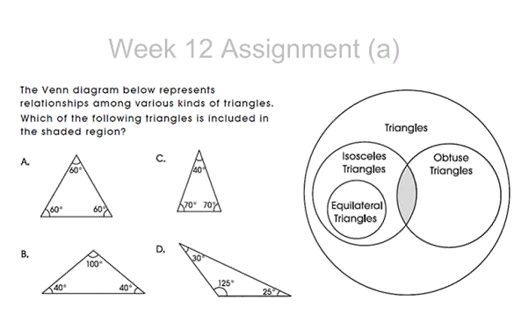

Triangle B.

It has two equal sides and an obtuse angle.